CS4402 Discussion assignment 8

Conduct research using the internet and the University of the People library to determine what types of computing problems are solved most efficiently using a Logic programming language such as Prolog.  As part of your response discuss a specific application and indicate what features within Prolog (or logic programming in general) make it ideally suited as a solution for your selected computing problem.

For example: Prolog is ideally suited as a programming language for the artificial intelligence routines within an industrial robot because  …

What types of computer problems are solved most efficiently using prolog.

Explain how the features of prolog resolve the problems that efficient using

Code examples

According to (*Prolog - Introduction*, n.d.), the prolog is well-suited to various types of program problems. Logic programming uses an abstract model that represents objects and relationships. and it computes by deducting the clauses and can separate the controls and logic.

Especially symbolic reasoning and rule-based decision-marking. It’s good for diagnosing programming systems like below.

The diagnose logic can be built with good separating with the diagnosis of facts and rules and this is thanks to the declarative nature of encoding of domain knowledge.

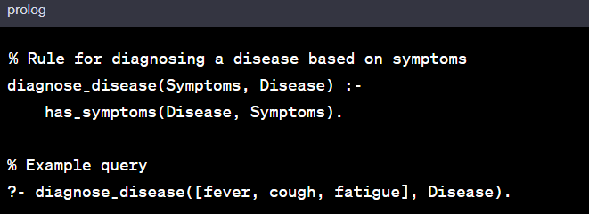

The prolog is great with natural language processing (NLP). The prolog is good with pattern matching and recursive parsing. It’s easy to build a parsing tree logic.

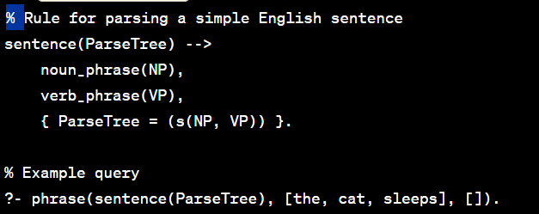

The prolog is equipped with backtracking and exploring alternative plans.

For backtracking, the prolog searches the truth value of different predicates by checking whether they are correct or not. The backtracking continues until it reaches the proper destination.

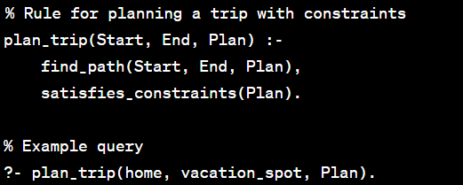

Prolog is also handy in constructing complex query logic with many constraints.

We can write clean code for querying databases with complicated conditions.

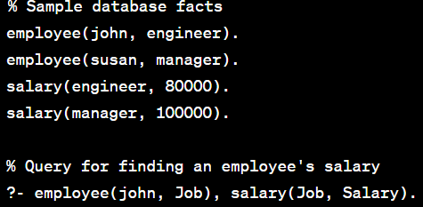

Overall, ProLog is great at solving complex constraints and boundary issues as well as the back-tracking ability.

**Reference**

*Prolog - Introduction*. (n.d.). Retrieved October 29, 2023, from https://www.tutorialspoint.com/prolog/prolog_introduction.htm